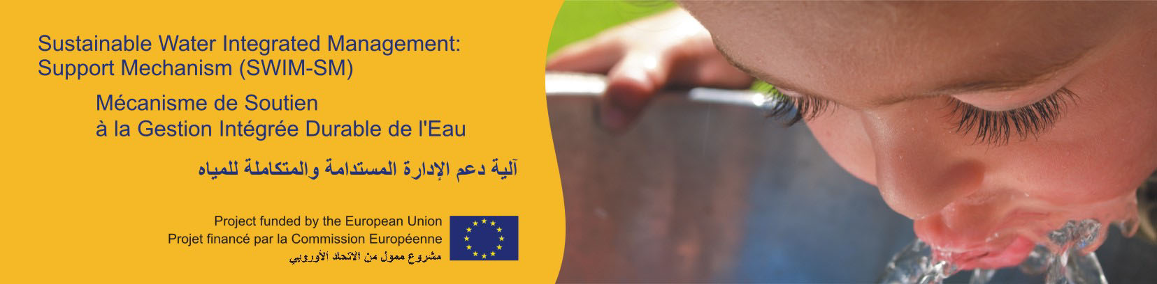

MAY 2012

EU funded Project SWIM-SM supports users’ participation in local water management
Press Note
Water users’ participation is a key component for the design and successful implementation of integrated water resources management and refers to a continuum of users’ involvement that grants them a greater role in management decisions.
Based on the need expressed by SWIM Partner Countries (PCs), the EU funded Project “Sustainable Water Integrated Management – Support Mechanism (SWIM-SM)” is implementing a set of activities directed to strengthen users’ participation towards a more effective local water governance and management with particular focus on Water Users Associations (WUAs).
To this respect a two-day regional workshop involving experts from the PCs was organized on 23-24 April 2012 in Athens with the aim to a) promote sharing of experiences and best practices in the establishment and operationalization of WUAs in the region and b) discuss / validate the findings of a Regional Assessment illustrating the range of experiences – both successful and less successful - in water users’ participation with regard to irrigation, complemented with specific case studies coming from Egypt, Jordan, Lebanon and Tunisia. The Regional Assessment was conducted in cooperation with and input from the SWIM National Focal Points and involved stakeholders.
Twenty (20) international, regional and local experts from seven countries participated in the regional workshop, including representatives of governments, WUAs, regional organisations and donors in addition to non-governmental organisations involved in the establishment and empowerment of WUAs in the region.
Among outcomes, the workshop identified gaps and concrete follow up actions for the SWIM-SM Project to undertake, including targeted capacity building and trainings in order to improve local water management and reinforce users’ participation in irrigation management.
The participatory nature of the workshop, comprising of countries’ presentations and breakout workgroup sessions, was highly valued by the participants according to whom “this has provided an opportunity to learn about other countries’ achievements; providing information on the lessons learnt and best practices in participatory irrigation management (PIM) and task transfer to WUAs and; allowed countries where the experience in PIM is still immature, or in its beginning, to learn about the enabling environment for the establishment and/or operationalization of WUAs”.
Opportunities for networking between the countries’ representatives and international, regional and independent experts were also created.
The workshop falls under one of the four thematic pillars of the SWIM project involving enhancement of knowledge on ‘water governance at the local level’ with emphasis for the first year on experiences in PIM and irrigation management transfer for WUAs in the region.
For more information:
Eng. Suzan Taha – Key Water Expert
e-mail: s.taha@swim-sm.eu
Tel.: +962 777 397 222
SWIM website: www.swim-sm.eu

Note to editors:
The SWIM Programme
Sustainable Water Integrated Management (SWIM) is a Regional Programme launched by the European Commission to contribute to the extensive dissemination and effective implementation of sustainable water management policies and practices in the Southern Mediterranean Region. This is in the context of increasing water scarcity, combined pressures on water resources from a wide range of users, desertification processes and in connection with climate change.
The Programme, with a total budget of approximately € 22 million, is implemented under the European Neighbourhood and Partnership Instrument (ENPI), following the Euro-Mediterranean Ministerial Conferences on Environment (Cairo, 2006) and Water (Dead Sea, 2008).
SWIM Partner Countries are: Algeria, Egypt, Israel, Jordan, Lebanon, Morocco, the occupied Palestinian territory, Syria and Tunisia.
SWIM consists of two major Components, which are inter-related and complement each other:
- A Support Mechanism, funded with a budget of € 6.7 million and
- Demonstration Projects funded with a budget of € 15 million
SWIM – Support Mechanism (SWIM-SM)
SWIM-SM is the Component of the Programme that provides Regional Technical Assistance to the Partner Countries. This Component, of the duration of 4 years (2010-2014), aims at:
- Providing strategic assistance to the Partner Countries in designing and implementing sustainable water management policies and plans, involving inter-sector dialogue as well as stakeholder consultation and participation;
- Contributing to institutional reinforcement, to the development of the necessary planning and management skills and to know-how transfer;
- Raising awareness on the threats on water resources, the necessity to switch to more sustainable consumption models and possible solutions to face challenges.
Furthermore, SWIM-SM also:
- assists technically the Demonstration Projects implemented under the second Component of the SWIM Programme and;
- undertakes Capacity Building activities related to water resources management identified under the Horizon 2020 Capacity Building – Mediterranean Environment Programme (H2020 CB/MEP).

SWIM-Support Mechanism is implemented by a Consortium formed by a combination of nine international and regional companies and institutions:
- LDK Consultants Engineers & Planners SA: Leader of the Consortium
- Global Water Partnership - Mediterranean (GWP-Med): SWIM-SM Technical Direction
- Arab Countries Water Utilities Association (ACWUA)
- Arab Network for Environment and Development (RAED)
- DHV B.V.
- Greek Ministry of Environment, Energy & Climate Change, Department of International Relations & EU Affairs
- Lebanese Ministry of Energy and Water, General Directorate of Hydraulic and Electrical Resources
- Tunisian Ministry of Agriculture and Environment, Bureau de l’Inventaire et des Recherches Hydrauliques / Direction Générale des Ressources en Eau
- Umweltbundesamt GmbH - Environment Agency, Austria

SWIM Demonstration Projects

- Adaptation to Climate Change of the Mediterranean Agricultural Systems (ACLIMAS)
Leader of the Project’s Consortium: International Center for Advanced Studies on Mediterranean Agriculture – Mediterranean Agronomic Institute of Bari (CIHEAM-MAIB), Italy

- All Across the Jordan: the Trans-boundary NGO Master Planning of the Lower Jordan River Basin
Leader of the Project’s Consortium: Friends of the Earth Middle East

- Innovative Means to Protect Water Resources in the Mediterranean Coastal Areas through Re-injection of Treated Wastewater (IMPROWARE)
Leader of the Project’s Consortium: Italian Ministry of the Environment, Land and Sea

- Sustain Water MED: Network of demonstration activities for sustainable integrated wastewater treatment and reuse in the Mediterranean
Leader of the Project’s Consortium: Deutsche Gesellschaft für Internationale Zusammenarbeit ( German International Cooperation - GIZ) GmbH

- Water harvesting and Agricultural techniques in Dry lands: an Integrated and Sustainable model in MAghreb Regions (WADIS MAR)
Leader of the Project’s Consortium: University of Sassari, Italy

