What is SWIM-Support Mechanism (SWIM-SM)?
Sustainable Water Integrated Management –Support Mechanism (SWIM-SM) is the Component of the overall programme providing strategic and technical assistance to the Partner Countries (PCs).
Such assistance unfolds into six main types of interventions related respectively to:
1- Water governance and mainstreaming of water considerations into other sectoral policies and strategies;
2- Capacity building and empowerment of water related stakeholders so that they can assist in the planning and development of water resources management in a holistic manner;
3- Application of water management plans by strengthening intra sector and inter-sector dialogue and contributing to the harmonization of approaches and policies;
4- Identification and promotion of good practices and success stories on water management and de-pollution of the Mediterranean;
5- Communication and awareness raising activities relevant to the topics of the project and;
6- Support to the European Commission with the overall implementation of the SWIM Programme and particularly of the SWIM Demonstration Projects (the second component of SWIM Programme) , to ensure interaction and fruitful coordination among them and between them and the Support Mechanism.
Based on the analytical work realised during the SWIM-SM’s Inception Phase (January-August 2011) and the identification by Partner Countries (PCs) of prominent issues of concern for their water sector, four main thematic Pillars have emerged as regional priorities, around which SWIM-SM activities are structured and implemented. These are:
A- Non-conventional Water Resources;
B- Economic valuation of Water Resources;
C- No-regret Actions for Climate Change Adaptation;
D- Local Governance
The six Work Packages cut horizontally across the four thematic Pillars and SWIM‐SM proposes activities that address both the Pillars and the horizontal components so as to provide the flexibility required for the PCs to select appropriate activities consistent with their national priorities for the water sector (see image below). A key element of the selected activities concerns the replication potential, so that even if an activity is implemented within the national context the experience has applicability/transferability in more PCs.
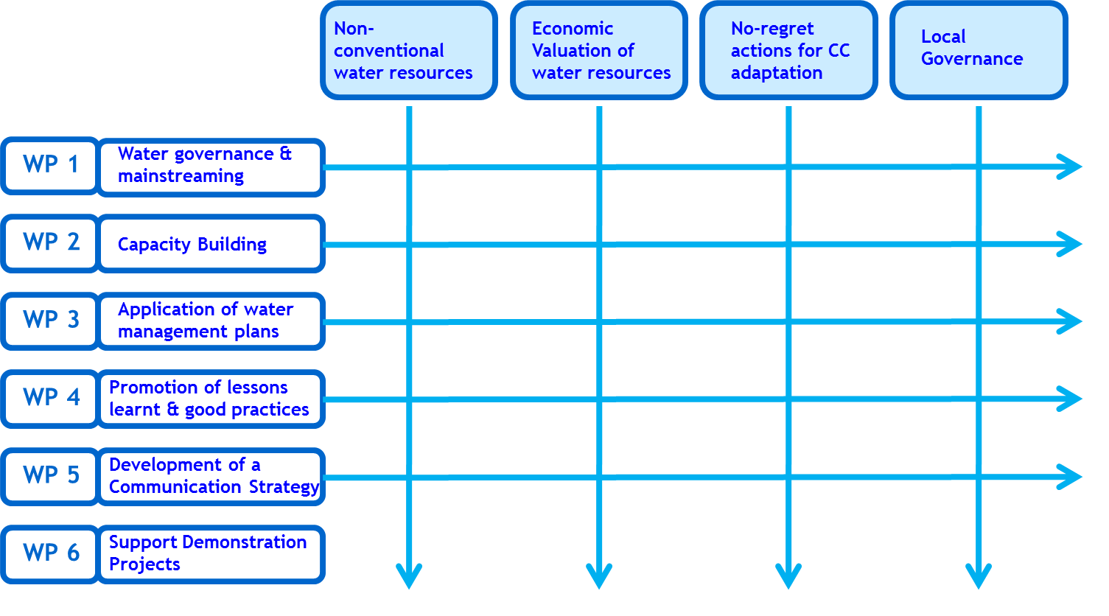

The SWIM Demonstration Projects complement SWIM-SM interventions by further supporting the implementation and wide dissemination of good practices and state-of-the art technologies at national and regional levels in relation to the above identified priorities and particularly:
- Non-conventional water resources management, with focus on wastewater treatment and reuse and the recharge of aquifers,
- Water and Climate Change Adaptation, with emphasis on water and agricultural management and
- Water Governance in a transboundary context.

